Wednesday, April 15, 2020

Carrying over from my previous week, this is my list of goals for this week. I’m tentatively planning on initial test flight this weekend (or next week), but there are some challenges. Esp my current lack of a propeller for the left front motor.

Week of: April 13-17
- Investigate the necessity of having landing gear on the igloo aircraft
- If necessary, re-mount the landing gear on Igloo aircraft.
- Test-install the left motor-arm
- Finish the power wiring harness
- Figure out how to read the signal from new RPM sensor
- Figure out how to save and/or export the motor rpm data
- Finish fiberglassing the right motor-arm
- Finish building the right motor-arm
- Put together the signal wiring harness.
- Glue Signal wiring harness
- Finish the full construction and integration of VTOL motors, including wiring.
- Integrate the pixhawk on the Igloo airframe.
- Finish software setup and prepare for hover testing.

Today I finally mounted the left-side motor-mounting arm.

I also ordered the necessary 14 x 8.5EP propeller from APC propellers. I need this to resume flight testing.

I ordered myself a pixhawk kit and two motor-rpm sensors. I did not splurge and buy the Holybro version. Instead, I got a knockoff from amazon for a total price of ~130. I think it’ll work, and it has integrated pwm outputs, so I **shouldn’t need an external power distribution board.

April 20, 2020
Today I finished wiring my 4-way splitter for the wiring harness. I have not, however, wired on the plug for connecting to the I/O Power distribution board.

I also got an RPM sensor from Hobbywing. This connects to any 2 of 3 motor leads, and outputs a conditioned signal you can read with a microcontroller. There was almost no documentation on how to read the signal, but I asked around and figured out a small arduino (nano) script to read the signal, calculate the rpms, and output it to the serial port. The hard part, of course, will be integrating onto the aircraft, logging the data, and storing it. Ideally, it would be amazing if I could import it into the pixhawk’s own flight log, but that seems highly unlikely with my skill level. Also ambitious, and probably overkill, would be to make a custom PCB to integrate this functionality (preferably with inputs for 4 motors). Heck, if it works, I could even put it online and/or try to sell them cheap. Probably ambitious for now.

April 21, 2020

I installed the left forward propeller (which came in 1-2 days ago). Unfortunately I am missing the nut and washer from this motor, so I borrowed one from my Evolution 46 engine. I am not really sure why this worked, because the two nuts have very different outer (wrench) sizes 10mm vs 11mm/(7/16”). It fit, though, so I went with it just because I know I shouldn’t (because of the pandemic) go to the store in an attempt to replace it.
I made a fair amount of progress today. The primary thing was I removed the pixhawk, power distribution board, and receiver from Muse and started to do a test-integration into the Igloo test aircraft. I was careful to keep track of what was plugged into what on Muse. I also wrapped a rubber band around all the pwm connectors going to main flight controllers. I did not extend the clipped nose with foamboard like I originally planned to, and that’s partially because I’m lazy but also because it might be better this way. I realized that the aircraft (igloo 23) no longer has a motor hanging of the nose of the aircraft, and so it will likely make sense to shift the wing back to where the CG wants to be. In theory, this reduces the moment arm of the tail, but I think that’s okay.

I had some issues with the pixhawk after I loose-installed it into the igloo aircraft. First, it wouldn’t allow me to arm it because the sensor data was not properly calibrated (I suspect that’s because I removed both the GPS and pixhawk from the original aircraft and their compass values likely differed slightly. But it wouldn’t give me the option to calibrate it because it thought the aircraft was flying…. The aircraft wasn’t even armed. I did a little searching, and it sounded like that was a bug in a particular version of either qgroundcontrol or pixhawk firmware. I updated the pixhawk firmware and the problem fixed itself. I did not calibrate the compass (and other sensors), however, because the fuselage is not yet connected to the wing in its new location. At this point, I went down a brief rabbit hole because I wanted to see if I could get the Airspeed sensor I have working. Firstly, I plugged it into the 6.6v ADC pin on the I/O Power Distribution board. Then I looked for the ARSPD_PIN parameter, which you are supposed to use to specify the input for the airspeed sensor. It wasn’t there. I looked it up and found very little, if any, discussion of that fact. I also did not find the parameter where you specify analog vs digital airspeed sensors. I then continued to look through the parameters and read forums. Then I did the following:

I changed FW_ARSP_MODE from 2 to 0
I changed CBRK_AIRSPD_CHK from 162128 to 0

Essentially these should enable the pixhawk looking for the airspeed sensor. At this point, it was looking for an airspeed sensor but not finding one. I looked closely at the I/O power distribution board and realized that the pin I had it connected to required another connector (the CAP ADC 8-pin connector). I don’t have it, so I’m not sure what I’m going to do about that yet. I might just have to wait until my pixhawk comes in. I think I can connect the airspeed sensor directly to the bottom of that flight controller.

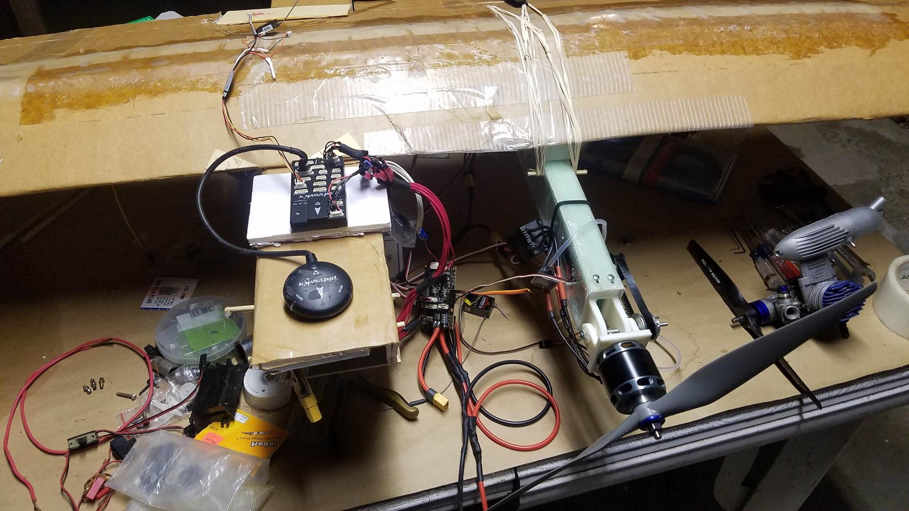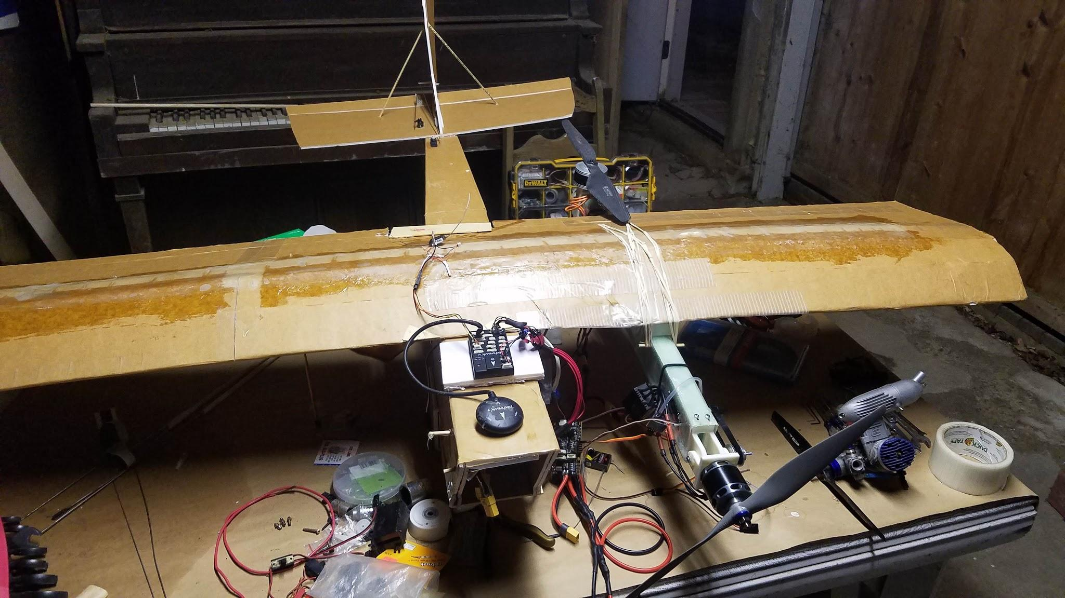

As of right now, all the electronics are sorta haphazardly draped over the airplane and nothing is finalized. Unfortunately this re-positioning of the electronics, if I stick with it, totally screws up my electrical integration scheme.

On an unrelated note: have a few concerns.
- Firstly, about the forward VTOL mounts. Due to the tension of the belt, the whole motor is at an angle. I’m not sure exactly how much, but it is significant. Ideally, I could reverse the opposite side, but I don’t want to do that if I don’t have to because I would have to reverse one of the pivot servos.
- Also, I have noticed slipping between the motor-pivot (screw) axis and the aluminum pulley. This is likely due to the fact that the screw is threaded. I’m not entirely sure what to do about that. I guess I could try to grind it down using dad’s bench grinder or a good tool on my dremel. I re-adjusted and re-tightned this assembly today, but I’m going to be watching closely to see if the problem comes back.
- As previously mentioned, I’m concerned about the rigidity of the connection between the motor-arms and the wing. This is especially an issue for transferring forward thrust, because it is not currently directly constrained in that axis and the rubber bands can easily shift to accomodate different positions. Granted, I could try to increase the number of rubber bands, and I probably will, but that’s only going to do so much and there is a practical limit to the amount of compression force that wing can stand. Part of the problem is that a large forward thrust will cause the arm to slide forward and the aft props can interfere with the wing. They’re already super close together as it is. One partial fix to this last problem is, of course, to print taller motor mounts. That’s 100% an option, and seeing as the current aircraft is NOT aerodynamically efficient anyway, it’s not a bad one….

April 22, 2020
Okay I accomplished a lot, but I also hit some big road-blocks today.

I finished fiberglassing my right motor-mounting arm today.

For some unknown reason, the pixhawk is no longer recognizing the receiver properly. Suddenly I am getting the error: “Detected 0 radio channels. To operate px4, you need at least 5 channels.” I get the feeling that this is not going to be easy to fix.

April 23, 2020

The new fiberglass arm came out beautifully. Of course there’s air bubbles in some places and too much epoxy in others. Despite the imperfections, it should be pretty good for my purposes. Before this particular fiberglassing operation, the part had a mass of 120g. After this fiberglassing operation, the final arm came in at about 146g.

April 24, 2020

Today Project Goals:
- See if the pixhawk problem persists
- If yes, then try updating the firmware with my older computer. See if it persists
- Solder the final connector onto my power wiring harness
- Assemble the right VTOL motor mount arm
- Calibrate the compass
TBD:
- High-level system analysis of “final” aircraft?
- Name the darn thing

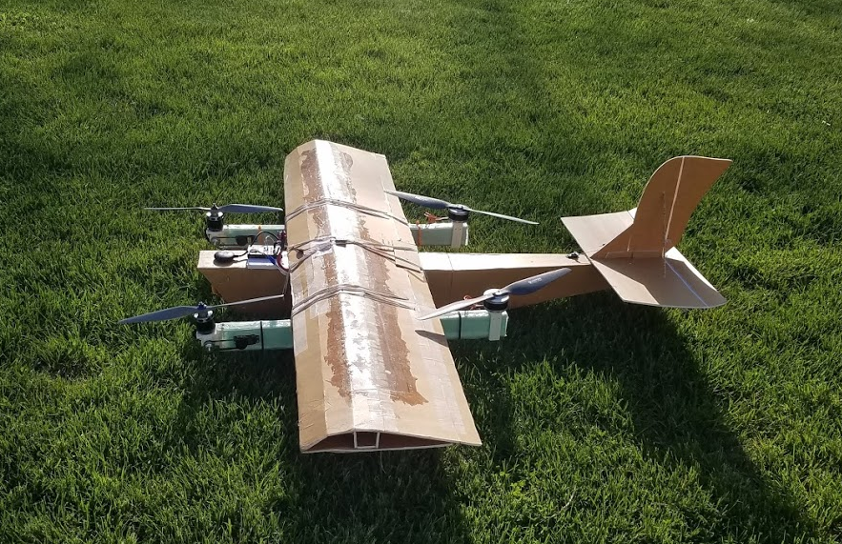
Igloo test aircraft, almost fully integrated. It’s sure not perfect, but it’ll be a “good enough” test-bed for my new VTOL motor mounts, the pixhawk flight software, and some experimental VTOL technologies I want to try out.

April 28th, 2020

SYS_AUTOSTART from 13015 to 0 (it seems 13015 is the value for our tilt-rotor config)

SYS_AUTOCONFIG from keep parameters to default

Hover flight test today! -- Unfortunately in Quadrotor mode. More on that shortly.

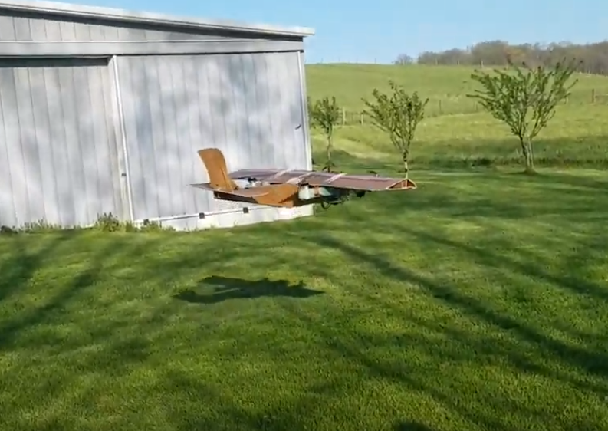
Hover-testing the aircraft in quadcopter mode. This was successful, but the stabilization-gains were all wrong. This is totally to be expected because the stock gains are for a quadcopter--not a quadcopter with an airplane attached.

These initial hover flights were not very stable. I saw lots of oscillations, which are of course because this “quadcopter” has an airplane attached and therefore the moment of inertia is super high.

Earlier this week, I realized that the power distribution board is just that: it has (i think) 8 sets of outputs for motors and other things like that. This is great, but it’s hard to know how much current can safely be draw through there. I would be worried about burning it out with my motors. Also, I’ve already soldered up my whole power wiring harness. But the thing is, looking at the data from today’s hover test flights, I realized that the pixhawk measures the current draw from the battery…. So I’m missing out on a solid data channel that would be very useful during flight test.

Persistent Pixhawk Software issue: This is the reason I did that initial hover test in quadcopter mode, instead of our custom VTOL aircraft configuration (used on Muse). So at some point in the past week or two, I started having an issue where the pixhawk would not recognize my transmitter/receiver. It’s definitely a software issue. I could not get the issue to go away by playing with the settings and/or calibrations. Finally, I started switching airframe profiles. Essentially, I told the airplane that it was a quadcopter. This fixed the issue. Switching back to our VTOL configuration made the issue come back. That’s why I ran the hover test in quadcopter configuration. I figure my only option at this point is to try to rebuild the custom configuration, which requires rebuilding the entire pixhawk flight stack. I don’t remember how to do this, and I think Gabe actually executed it last time. So that’s going to be a holdup for at least a few days.

May 1-3, 2020

I’m writing this after the fact, because I’m not sure which day it was. I was doing some basic hover testing in my yard with my in-progress controls profile, and I started to see structural oscillations in the airframe that led to the disconnection of the right-side motor mount rubber bands. The plane landed on its left wingtip (in the grass), and the right motor arm disconnected from the main wing. Fortuntely, overalll damage was minimal. More importantly, it effectively confirmed that my wing-motor mount connection utilizing just rubber bands was NOT going to be sufficient. Kinda stinks, but this was a relatively low-cost way of finding out.

May 4th, 2020

So I had lots of issues with my new version of the flight software. I was working on them until Gabe finally got back to me with the old files from Muse. I’m happy to have a stable firmware to use, but I’m annoyed because I spent about a week discovering how to make these configuration and mixer files and then rebuild the pixhawk code base. But all that’s done now.

Thanks to Gabe sending me the old files from Muse, the aircraft is now essentially software-ready for flight. I just need to address the flexibility issue between the motor arms and the main wing. I have come up with a new 3d-printed bracket to replace the 3d-printed spacer (between the wing and motor-arms) I was using. The unfortunate reality is I decided the only doable way of mounting this on there with any additional rigidity is to hot-glue the new spacer-mount to a piece of balsa, which is to be hot glued to the main wing. Then the motor arms are screwed (with 4-40 machine screws) into the 3d-printed spacer/brackets. Then I go ahead and add the rubber bands back where they were. I still have the rubber bands holding everything together (and supporting the glue joint), but the hot glue joint constrains any motion in the span-wise and rotational axes. This is not a bulletproof solution, as it may be a little weak, but I’m hoping it will be enough to keep everything together. Hopefully it’s enough to keep the aircraft from doing the structural oscillations that it was doing last time.

After installing the “muse” firmware, it became obvious that the roll (and probably pitch) control was way too sensitive. This is the same behavior we saw flying on Muse, and the cause of the front-left motor breaking off. I’m going to see if I can decrease this prior to actual flight tests.

May 5th, 2020
List of issues with my new pixhawk:

- Elevator is not working
- One compass is bad or getting bad signals or something. This could be related to the battery and power board being directly underneath it.
- Receivers are really jittery - Esp when the tx is plugged in to the flight controller
- I can’t calibrate the ESC because of some firmware bug or something. Also, when I ‘soft’ arm it, the ESC beeps loudly like the signal going into it is too large.
- The pixhawk is claiming that the avionics power is low. I’m not sure why.

Also: the rudder servo becomes much less jittery if I merely touch the wires leading to it. This is probably some sort of interesting EMF effect.

Mitigations to try:
- Move the battery and avionics-power supply thing away from the board and GPS/compass.
- Check the outputs for the servos, and maybe try moving them around.
- Try changing the firmware version, if necessary. I could rebuild the Muse firmware for this purpose, but I’ll probably have to accomodate for the different hardware.

May 6th, 2020

Rebuilt the motor-arm attachment points on Igloo 23 VTOL, as planned. I think these will probably work. Soon more-involved hover tests will let me know if that’s correct. Also, I finally got around to sanding the fiberglass on top of the main wing. I think this will be good from an aerodynamic standpoint, and it should reduce the frequency with which I scrape my hands on the pointy fiberglass ends. This has been a problem.

To-do:
- Secure the aft motors with fasteners
- Turn down the control gains in multicopter mode. I think this is the following variables:
  - MC_Rollrate_MAX
  - MC_PITCHRATE_MAX
  - MC_YAWRATE_MAX
If this doesn’t work, worst-case scenario, I can turn on control expo.

Parameter changes prior to flight:
- Changed MC_PITCHRATE_MAX from 220 deg/s to 200 deg/s
- MC_Rollrate_MAX from 220 deg/s to 150 deg/s
- MC_YAWRATE_MAX from 200 deg/s to 100 deg/s

I’ll start here, but it’s likely that I’ll have to adjust the stabilization gains.

Flight “1” done. 6:43 PM

During flight, I put in several (radio) trims to control wandering.

Okay, so I need to turn these values down further:
- Changed MC_PITCHRATE_MAX from 200 deg/s to 100 deg/s
- MC_Rollrate_MAX from 150 deg/s to 100 deg/s
- MC_YAWRATE_MAX from 200 deg/s to 70 deg/s

I’m going for docility. Large, sudden rate inputs can lead to structural modes or failures right now.

Changed:
MC_ROLL_P from 6.5 to 7.5
MC_PITCH_P from 6.5 to 7.5

Flight 2 done: ~7:53 PM

Definitely feels more docile, and a little more stable. I think increasing P gains was correct.

I landed early because the aircraft was wandering and I realized I never cancelled the radio trims.

I changed TRIM_ROLL from 0 to .05 to see if it’s the right direction. I removed the radio roll trim, which was at +32 (right).

I changed PITCH_TRIM from 0 to .05, and removed the radio trim of +8

Not only did it feel like an improvement, but the data in the log looked a little better, so I
Changed:
MC_ROLL_P from 7.5 to 8
MC_PITCH_P from 7.5 to 8

Flight 3 8:11 PM
This flight was very short because I started seeing significant i-windup (or something) that led to rapid oscillations upon taking off.

Flight 4 8:14 PM
On this flight, I wanted to try again, basically. I wanted to understand what was wrong. It turned out to be a pretty long flight. Here’s my initial reactions:

- The roll and pitch sensitivities are a little low, but effective.
- The trim seems improved but needs refining.
- I still saw those oscillations, and I think they’re in the yaw axis.
- The Pitch and roll axes are close, but are seeing some overshoot. I’ll have to look into how to fix this.
- I still saw that windup-to-oscillation problem upon takeoff in (i think) the yaw axis. Then I saw some oscillations in-flight. Again, I think this is in the yaw axis, but it could also just be in the pitch and roll axes coupled.

As an experiment, I am changing MC_YAW_P from 2.8 to 2.4 to see if that oscillation goes away or changes. Otherwise, it may likely be a pitch-roll problem.

Flight 5 8:33
So I crashed the aircraft. Damage wasn’t bad, but will take a few hours and some 3d-printing. Also I need to double-check my (hot) glue joints.

I spent much of this flight trying to re-create that oscillation I noticed in the previous flight (or two). It popped up while I was hovering in the sideways direction (i.e. a constant roll input), and in a few other cases I don’t completely remember. It was pretty unpredictable, but of course it usually felt related to control inputs. Anyway, this oscillation got bad at one point and the aircraft flipped over (falling out of the sky). Hence the crash. Fortunately it landed mostly upright, but kinda nose-down, so there was minimal damage. I’ll have to re-print the right-front 3d-printed motor mount and re-assemble it, but that’s not a big deal. Also, the right aft prop dug into the right aileron, destroying it. I’ll have to fix that too.

I think changing the MC_YAW_P parameter may have been a bad idea, because the vehicle seemed to wander more in the yaw axis (prior to the crash, of course). I did not get the feeling that this parameter had much influence over this oscillation.

Sadly, my phone was dead and I do not have video.

Results of data analysis:
After looking at the data, I think that the “oscillation” problem comes from the aircraft maxing-out its yaw control in an attempt to bring the nose of the aircraft around. That means that the pitch and yaw control are coupled together with the other two motors. I’m not entirely sure why the “oscillation” happens, per say, but I can definitely see how the control system would be limited in that case. In the case where the aircraft crashed, the aircraft had been hover-traveling with substantial speed while attempting to maintain a yaw angle inconsistent with the direction of travel. The plane was trying to yaw to the right, while the aircraft’s passive aerodynamic stability wanted the plane to weathervane to the left. The yaw controller maxed out and the oscillation started between the other two motors, leading to the aircraft flipping and crashing. I believe this maxed-out state can also lead to a net loss in thrust. The significance of this of course depends on the current aircraft mass.

Solutions, in order of viability:
- This can be (partially) avoided operationally by not hovering the aircraft sideways (or cockeyed) more than is absolutely necessary.
- Look for a parameter in the settings that will allow me to limit the yaw controller, so it can’t “max out.” The downside is that the aircraft does not have enough authority to hit the yaw setpoint in certain flight conditions, leading to point 3.
- Make the aircraft less aerodynamically stable in the yaw axis.
- See if it is possible to adjust the pitch and roll controllers so that the aircraft is relatively stable when it gets into this “maxed-out” condition.

Funny enough, solution 3 is sort of an inherent goal of this project (to happen later). Also this maxed-out condition is often happening during takeoff, which is a problem. Probably one soltion to avoid that is to throttle up more quickly.

May 8, 2010
I finished repairing the aircraft and readied it for another short hover flight. One of my main objectives was to reduce the yaw integrator limit in an attempt to eliminate the possibility of it “maxing-out” the yaw control again. This was my only change for flight 6. I did so via:

Changing MC_YR_INT_LIM from .3 (default) to .18

Flight 6:

Admittedly it’s hard to tell when there is a gust of wind or when the aircraft is out of trim. As far as I can tell, the vehicle did not “max-out,” but I did notice significant vibration of a similar type at certain points in the flight. This needs to be investigated further and hopefully eliminated. I think the oscillation is probably somehow related to the already-high overshoot in the pitch and roll axes.

The pitch and roll angular rates have very high-frequency oscillations. I think that is a sign of a rate P gain that is much too high. This is consistent with the Angle P gains, which were also much too high (I decreased those earlier). The roll and pitch angles are mostly correct (accurate), but they have high-frequency noise of a substantial deviation. I think this is a sign of the high-frequency oscillations in the rate controllers.

Also, the flight log shows multiple radio-cutouts. I’m not entirely sure the cause of these, but I need to watch out for them. I am looking at when they happen and what the status of flight was at that point.

For flight 7, I will:

Decrease MC_ROLLRATE_P from .150 to .120
Decrease MC_PITCHRATE_P from .150 to .120

If rollrate does not respond how I intend, I can also try increasing the D gain.

May 8, 2020
Flight 7:
During/after this flight, the forward motors shifted in their pivot axes again. This could be a large problem going forward, and might warrant a total re-design of the pivot system.

Changed: MC_PITCH_P from 8.0 to 7.0
MC_ROLL_P from 8.0 to 7.0

Flight 8:
This felt more relaxed in both axes, although there was a moment where it felt like the aircraft approached a diverging oscillation again. Looking at the data, I think I need to continue to decrease MC_PITCH_P and MC_ROLL_P.

MC_ROLL_P from 7.0 to 6.0
MC_PITCH_P from 7.0 to 6.0

Flight 9:

This felt like a large improvement in stability. It’s certainly not perfect, but it’s getting closer.

I think moving forward, I need to do robustness-testing. Until now, I’ve been flying very cautiously (for good reason), but I think I need to start pushing the limits and seeing what the plane can really do. I need the hover control to be pretty robust if I’m going to have a shot at a succesful transition.

Other comments:
- I think I might make the aircraft less aerodynamically stable (in yaw) and/or decrease the yaw control. In a cross-wind, it’s still at risk of instability.
- It remains to be seen whether I will try position hold/position/mission control before or after initial transition attempts. Both have risks associated.
- I am considering a flight attempt in acro mode to directly investigate the tuning of the rate controllers. Some research on the acro mode gains is needed prior to making this decision.
- I am watching the pivot mounts closely. They haven’t been a huge problem, but typically after I land, they are no longer vertical. This problem could quickly escalate.

Before flight 10:
Decreased MPC_XY_P from .95 to .8
Decreased MPC_Z_P from 1.0 to .8
Flight 10:
I had two objectives during this flight. Demonstrate some amount of “control robustness,” and try out position hold control. I went ahead and decreased the two above gains because most of the stock gains have been too high for most purposes so far.
I took off, flew up the hill, and gained altitude. Eventually, I put it into position hold mode. The aircraft responded suddenly, pitching back very sharply (it must have been still moving). I put it back into stabilized mode almost immediately and the aircraft slowly recovered. By the time I had it under control, it was over the Rittenhouse’s (neighbors) opposite field.
I want to try again, with different gains, of course.
Decreased MPC_XY_P from .8 to .3
Decreased MPC_Z_P from .8 to .3
Max groundspeed of ~27.7 km/h, or 7.7 m/s. This is considerable, but not quite the speed required for fixed-wing flight.
Max altitude ~22m
Flight 11:
This flight was decent. I demonstrated position hold mode without the plane totally “losing it.” The aircraft was fighting some headwind, though, so I think that limited its performance.
Not as severly as Flight 10, but this flight did demonstrate a decent ability to recover from severe attitudes. I’m feeling more comfortable about going to initial transition attempts tonight if the airspeed sensor doesn’t become a problem (it might).
During this flight, the aircraft hit an estimated 25 m and 16.1 km/h of groundspeed.
For some reason the aircraft is not shutting down the aft motors in FW mode on the ground. I can’t figure out why. I even thought that muse did shut down its aft motors. The only plausible explanation would be if the aircraft thinks it needs to transition first… which would be weird.
Flight 12:
I intended to try a transition on this flight, but quickly realized that when put into FW mode on the ground for a run-up test, all four motors still spin. I have set the VT_FW_MOT_OFFID parameter to 24 (the channel numbers associated with the aft motors). Also, I set the parameters such that the aircraft knows it's a tilt-rotor. The problems persist.

The only theories I have are:
- - I don't have an active airspeed sensor, so maybe the flight controller refuses to actually go into FW mode. But it does pivot the forward motors, so this seems sketchy to me.
- - The aircraft thinks that it must try to "transition," even though it's on the ground. That way it might run all 4 motors until it gets moving and then shut off the aft motors.
Neither of these explanations seems sufficient, so I’m not sure what to do. During the initial flight tests of muse (in august), the aft motors were turned off in fixed-wing mode. It is worth noting that that flight test was done in manual mode.

Crash attempting to go from acro mode back to stabilized mode. The aircraft reacted sharply. The resulting divergent oscillation well, diverged. Damage is very similar to the first crash, but a tad more severe. I need to also re-attach the pixhawk and GPS.
I am going to try printing the replacement motor mount out of PLA. Because the divergence came back so badly, I’m going to strongly consider adjusting the gains further. Exact changes are TBD.
Flight 13:
I decreased:
MC_YR_INT_LIM from .18 to .14
MC_ROLL_P from 6 to 5
MC_PITCH_P from 6 to 5

Results were mostly inconclusive due excessive wind.
Flight 14:
I am going to try again with the same settings.
Flight success, but there was a fair amount of that oscillation still.

Okay so I want to consider a few things:
- The “oscillation” I am seeing has to do with the yaw maxing-out and the pitch and roll coupling together.
- I’m wondering if the pitch and roll are also coupling together because the pitch and roll gains are the same.
- Looking at the data from this flight, I think it looks like pitch axis is following the setpoint relatively well, but the roll axis is not. I’m going to continue to decrease the p value for the roll axis, but not the pitch axis (for now).
I Decreased MC_ROLL_P from 5.0 to 4.0
Moving forward, I want to see how this affects the oscillation tendency. I don’t expect it to just disappear, but it might help.
Also, moving forward, I might cut off the top of the vertical tail to decrease the aerodynamic contribution to the yaw-induced oscillation. (I didn’t).
Flight 15
Initial reaction: The aircraft flew decently well. The oscillation was still there, generally, but it felt far less frenzied. I think it was a net improvement in flight qualities.
I am generally annoyed that the pixhawk multicopter angle controller is simply a P-controller (rather than PID), but I guess it simplifies the tuning process.
Reviewing the data more, I think the pitch and roll gains can continue to come down.
Also: I set new trim settings on the past two flights. It’s not immediately obvious why this was necessary, but whatever. I’ll have to “copy trims” using qgroundcontrol.
Decreased MC_ROLL_P from 4 to 3.5
I also did the “Copy trims” command.

Flight 16:
Flight successful. The control (and yaw-induced oscillations) definitely seemed a little less frantic.
Changed MC_PITCH_P from 5.0 to 4.0

Changed MC_YR_INT_LIM from .14 to .1
Changed MC_YAW_P from 2.4 to 2.2
Flight 17:
Plan is to take it to altitude, switch into acro mode, and then bring it back. I’ll do this over the long grass, facing into the wind.
Flight was a success. Overall, the aircraft was much more stable and switched in and out of acro mode like it was easy. The plane still kinda wants to yaw a lot (due to weathervaning). I would love to find a software workaround of some sort, but frankly that’s not the purpose of this project anyway.

May 18, 2020
Today I was thinking about the fixed-wing mode software issue that I’ve been having with the aircraft (about the aft motors not shutting off). I previously looked at the flight logs from the maiden flight of Muse, and I confirmed that the aft motors were NOT commanded to spin during that horizontal flight. Because the software was essentially the same, I went looking in the parameters for the difference.
Fortunately the flight log reader I use displays a specific listing of non-default parameters. I found my answer pretty quickly in two parameters that I did now know existed:
MT_MOT_COUNT allows you to declare the number of VTOL motors your aircraft has. On Muse, the number was set to 4. For my aircraft, this parameter was set to 0. This was obviously not correct, and correcting it resolved my issue.
WV_EN allows a VTOL aircraft to weathervane into the wind while hovering. This is a great (short-term) solution to the yaw problem I’ve been having. Whether this worked will not be clear until flight tests.

It seems the aircraft is now very close to ready for transition flights. The only potentially remaining issues:
- I need to make a final decision on whether my current pivot-mounts are “good enough” for an in-flight transition.
- Can I safely transfer sufficient forward thrust through the motor-arm mountings?
- Is the aircraft stable enough to recover from a bad transition attempt back into hover mode?
- Do a final once-over of the VTOL transition parameters.

